8/19/2018

Yu-Hong, Jhuo

Database Design Report

Computing For Free

Contents

Goal 2

Version Control 2

Normalisation 2

Column header 2

Pre-normalisation 2

First normal form 3

Second normal form 3

ERD 4

Decision issues 4

Separateness of Attendance and Booking 4

Using enrolment ID in Enrolment instead of using student ID and course ID 4

Using enrolment ID and session ID as composite primary key in Attendance instead of in Booking 4

# Goal

Create a database for recording session attendance of students and booking sessions.

# Version Control

GitHub:

<https://github.com/forestraindrip/BCPR203_Database_Management_Assignment>

# Normalisation

## Column header

Following items are column headers from “Basic fields for engagement spreadsheet.xlsx” provided:

* ID Number
* First Name
* Last Name
* Course
* PROG
* Start Date
* End Date
* Number of days attended
* Number of days
* Withdrawal point
* Last Withdrawal Date
* Attended past last withdrawal date?
* Date Last Attended
* Last Active Moodle
* Future Bookings
* Weeks Left
* Completed
* Notes
* Monday, 8 January 2018 (attendance date and time)

## Pre-normalisation

|  |  |  |  |  |  |  |  |
| --- | --- | --- | --- | --- | --- | --- | --- |
| ID Number | First Name | Last Name | Course | PROG | Start Date | End Date | Completed |

Following column headers are removed because they are derived attributes or data from external data:

* Number of days
* Number of days attended
* Withdrawal point
* Last Withdrawal Date
* Attended past last withdrawal date?
* Date Last Attended
* Last Active Moodle
* Future Bookings
* Weeks Left

“Completed” is kept, although it can be calculated by other attributes. However, there may be special cases of student enrolment which need to be manual examined and modified by the staffs.

“Notes” is removed because it is not directly related to the booking and attendance system.

“Attendance date and time” is removed and put into a new table Attendance because it has multiple values.

## First normal form

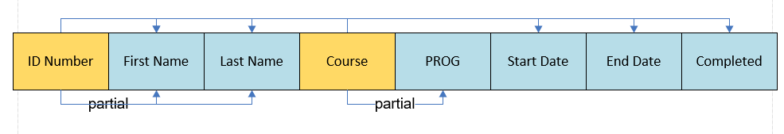

## Second normal form

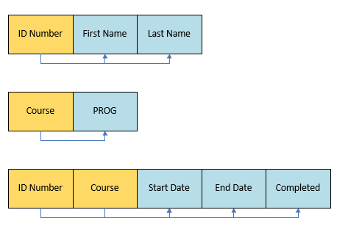

## Entity Relationship Diagram

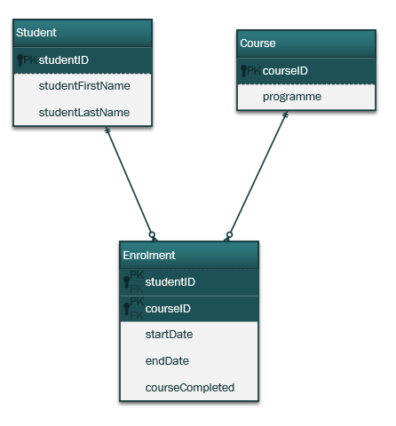

# Decision issues

## Separateness of Attendance and Booking

In the first design, Booking entity records the time a student attending the booking session. If there is no attendance time record, then we can know the student is absent from the booking session, so no Attendance entity existed. However, because student can attend a session without booking, Attendance entity becomes necessary to record the attendance date and time without referring to a Booking entity.

## Using enrolment ID in Enrolment instead of using student ID and course ID

In the final stage of normalisation in previous session, it uses student ID and course ID as composite primary key. However, a student may fail a course and enrol the same course again. If student ID and course ID is the composite primary key, both old and new enrolments will have the same primary key which creates duplicate data. Therefore, I use enrolment ID to prevent duplicate primary key for enrolment.

## Using enrolment ID and session ID as composite primary key in Attendance instead of in Booking

Both Booking entity and Attendance can use enrolment ID and session ID as composite primary. However, two entities use the same composite primary key may cause confusion for the users. On the other hand, the importance of Attendance is higher than Booking, using enrolment ID and session ID as composite primary key for Attendance is more convenient for the users to input data than using random ID. Therefore, I use random number as primary key for Booking and composite primary key for Attendance.